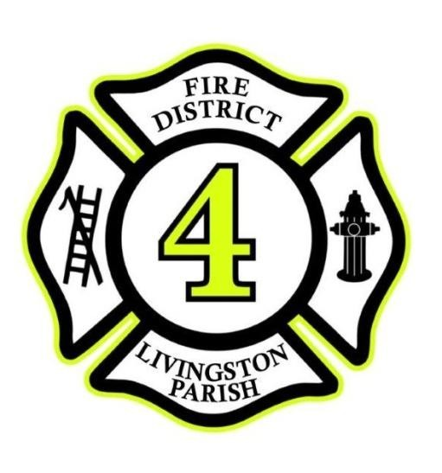

James T. Wascom 9760 Florida Blvd
Fire Chief Walker, Louisiana 70785
Phone (225) 664-7123
Fax (225) 664-6660 http://www.lpfpd4.com

NOTICE OF PUBLIC HEARING

The Board of Commissioners of Livingston Parish Fire Protection District 4 will hold a Public Hearing at
6:00 p.m., Monday, November 15, 2021, to discuss the Amendments to the 2021 Operating Budget and the 2022 Proposed Operating Budget. The meeting will be held at 9760 Florida Blvd (Headquarters), Walker, LA 70785.

No other business will be discussed in the Public Hearing.

Following the Public Hearing, the regular monthly meeting of the Board of Commissioners will be held. At this meeting, the amendments to the 2021 Operating Budget and the 2022 Proposed Operating Budget will be adopted.

Copies of the budgets may be viewed by all interested parties at the Administration Office of Livingston Parish Fire Protection District 4, 9760 Florida Blvd, Walker, LA 70785 between the hours of 7:00 a.m. and 5:00 p.m., Monday through Thursday.

By Order of the Chairman
Robert Dugas

To be published in The Livingston Parish News: October 21, 2021

